DEPARTMENT OF BIOLOGICAL, CHEMICAL, AND PHYSICAL SCIENCE

ILLINOIS INSTITUTE OF TECHNOLOGY

PHYSICS 123

Conservation of Energy

**Lab 7**

Markiyan Varhola

A20324717

Date of Experiment: Oct. 15, 2015

Due Date: Sep. 22, 2015

Lab Section: 03

Lab Partner: Bhav Bhalla

**Statement of Objective**

The object of this lab was to devise an experiment that would show the transfer of potential energy from a spring into kinetic energy of an object in a closed system. Also, the lab called for the creation of an experiment to show the transfer of potential energy of from a spring to the gravitational potential energy of the system.

**Theory**

The total mechanical energy of the system is defined as the sum of kinetic energy and potential energy.

*Equation 1: Total Mechanical Energy*

$E=K+U$

If a system is a closed system, and only has conservative forces acting on it, it will have a conservation of energy. Therefore, the total change of energy of the system will be 0.

*Equation 2: Conservation of Energy*

$ΔK+ΔU=0$

It is possible to modify this equation to to show the relationship between the kinetic energy and the potential energy of a system, using their respective equations.

*Equation 3: Conservation of Energy Conglomerate Equation*

$\frac{1}{2}k(Δx)^{2}=\frac{1}{2}mv{}^{2}$

The potential gravitational energy can be substituted for the kinetic energy equation to show the relationship between it and the potential energy of the spring.

*Equation 3: Relationship between potential spring energy and the potential gravitational energy*

$\frac{1}{2}k(Δx)^{2}=mgy$

**Equipment List**

* Air Track
* Masses
* Cart
* Wooden Blocks
* Ruler
* Economy Photogate Sensor
* **Safety Goggles**
* Force Sensor
* Spring Launcher
* Data Studio Software

**Procedure**

The spring force coefficient (k) was measured by pulling back on the spring and measuring the force required to keep it at a certain compressed distance. Afterwards, the equation F/x = k was used to separate the variables and obtain a value for k. Next, a cart of known mass was placed on an air track with a photogate sensor. The spring was pulled back a measured amount, and then fired, propelling the cart forward into the photogate sensor, which measured the velocity. This experiment was performed multiple times to ensure consistency. Next, in order to measure the potential gravitational energy, the experiment was set up in the same way. Wooden blocks were placed on the opposite end of the air track to provide an angled system. Then, a cart was launched using the spring launcher, and the maximum length that the cart travelled was measured. This was also repeated multiple times to ensure consistency.

**Data**

*table 1: calculating the coefficient of a spring*

|  |  |  |  |
| --- | --- | --- | --- |
| **F (kg/m)** | **X (change) m** | **k (N/m)** | **k (avg)** |
| **6.7** | **0.01** | **670** | **651.67** |
| **12.7** | **0.02** | **635** | **651.67** |
| **19.5** | **0.03** | **650** | **651.67** |

Experiment 1

*table 2: potential energy of the spring and the kinetic energy of the cart*

|  |  |  |  |  |  |  |
| --- | --- | --- | --- | --- | --- | --- |
| **m1 (grams)** | **v (Trial 1)** | **v (Trial 2)** | **v (Trial 3)** | **v (Average)** | **Potential Energy (Spring)** | **Kinetic Energy (Cart)** |
| 200 | 0.41 | 0.42 | 0.43 | 0.42 | 0.033 | 0.018 |
| 280 | 0.38 | 0.36 | 0.37 | 0.37 | 0.033 | 0.019 |
| 320 | 0.33 | 0.33 | 0.33 | 0.33 | 0.033 | 0.017 |
| 200 | 0.75 | 0.72 | 0.71 | 0.73 | 0.13 | 0.053 |
| 280 | 0.65 | 0.65 | 0.65 | 0.65 | 0.13 | 0.059 |
| 320 | 0.58 | 0.6 | 0.62 | 0.6 | 0.13 | 0.058 |
| 200 | 1.13 | 1.1 | 1.07 | 1.1 | 0.293 | 0.121 |
| 280 | 0.95 | 0.94 | 0.93 | 0.94 | 0.293 | 0.124 |
| 320 | 0.88 | 0.88 | 0.89 | 0.88 | 0.293 | 0.124 |

Experiment 2

*table 3: potential energy of a spring and the potential energy of gravity*

|  |  |  |  |  |  |  |  |  |  |
| --- | --- | --- | --- | --- | --- | --- | --- | --- | --- |
| **h (cm)** | **x** | **m1** | **l (Trial 1)** | **l (Trial 2)** | **l (Average) (mm)** | **Theta (deg)** | **y (sin(theta)/l) (CM)** | **Potential Spring** | **U Grav** |
| 2.5 | 0.01 | 200 | 555 | 572 | 564 | 1.05 | 1.03 | 0.03 | 0.02 |
| 2.5 | 0.01 | 280 | 440 | 415 | 428 | 1.05 | 0.78 | 0.03 | 0.02 |
| 2.5 | 0.015 | 200 | 1100 | 1050 | 1075 | 1.05 | 1.97 | 0.07 | 0.04 |
| 2.5 | 0.015 | 280 | 910 | 920 | 915 | 1.05 | 1.68 | 0.07 | 0.05 |
| 5 | 0.01 | 200 | 250 | 260 | 255 | 2.09 | 0.93 | 0.03 | 0.02 |
| 5 | 0.01 | 280 | 190 | 205 | 198 | 2.09 | 0.72 | 0.03 | 0.02 |
| 5 | 0.015 | 200 | 530 | 510 | 520 | 2.09 | 1.9 | 0.07 | 0.04 |
| 5 | 0.015 | 280 | 400 | 410 | 405 | 2.09 | 1.48 | 0.07 | 0.04 |
| 7.5 | 0.01 | 200 | 170 | 180 | 175 | 3.13 | 0.96 | 0.03 | 0.02 |
| 7.5 | 0.01 | 280 | 140 | 140 | 140 | 3.13 | 0.76 | 0.03 | 0.02 |
| 7.5 | 0.015 | 200 | 350 | 350 | 350 | 3.13 | 1.91 | 0.07 | 0.04 |
| 7.5 | 0.015 | 280 | 250 | 270 | 260 | 3.13 | 1.42 | 0.07 | 0.04 |

**Analysis of Data**

The spring constant for both experiments was 652 N/m, as it was calculated prior to beginning both experiments.

*graph 1: kinetic energy and the potential energy of the system*

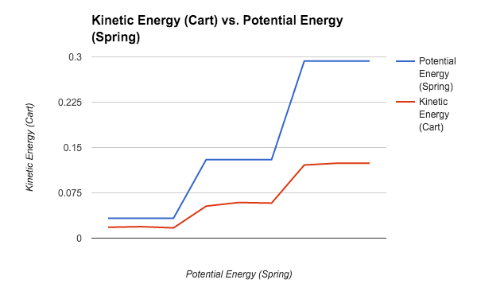

Although equation 3 calls for the conservation of energy, it must be noted that the system was not completely closed, therefore the potential energy was not completely transferred into the kinetic energy of the cart.

*graph 2: kinetic energy and the potential energy* 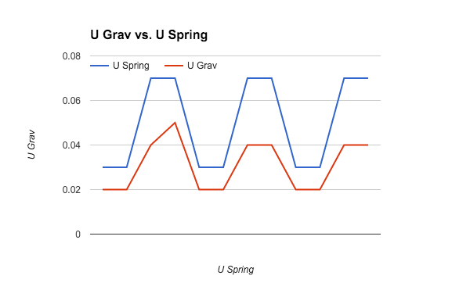

The graph shows the relationship between the kinetic energy of the system, as well as the potential energy of the system. Just like in experiment 1, the system was not completely closed, therefore some energy went out of the system.

**Discussion of Results**

Part 1:

The calculated value for the Kinetic energy of the cart in experiment 1 is generally lower than the potential energy of the spring. This is most likely because the system was not completely closed, and there were other variables which still existed. Friction, although minimized by the air track, was still present, and energy was therefore lost as heat. Also, the spring launcher cause a loss of energy through both heat and sound upon striking the cart. However, it must be noted that although the Kinetic energy of the cart was lower than the potential energy of the spring launcher, they both followed the same trend of increasing and decreasing as other variables were changed.

Part 2:

Just as in part 1, the calculated value for the potential gravitational energy was lower than the potential spring energy due to several external factors, such as heat and friction. However, both the potential energies increase as one increases, showing the relationship between them.

There were several factors that could have caused errors in measurements, such as:

* The spring produced heat and sound on impact
* The track moved, introducing energy into the system.
* Friction was present in the pulley system
* Slight variations in the actual mass of objects vs the measured value.

**Conclusions**

The physics laws meant to be tested by this experiment were supported by the results obtained from the experiments. Since the experimental data was very close to the

theoretical data, the experiment was done correctly, albeit with small sources of error.

**References**

1. Physics 123 lab manual, Experiment 5. http://science.iit.edu/sites/science/files/elements/phy/pdfs/2013_lab_123_5.pdf